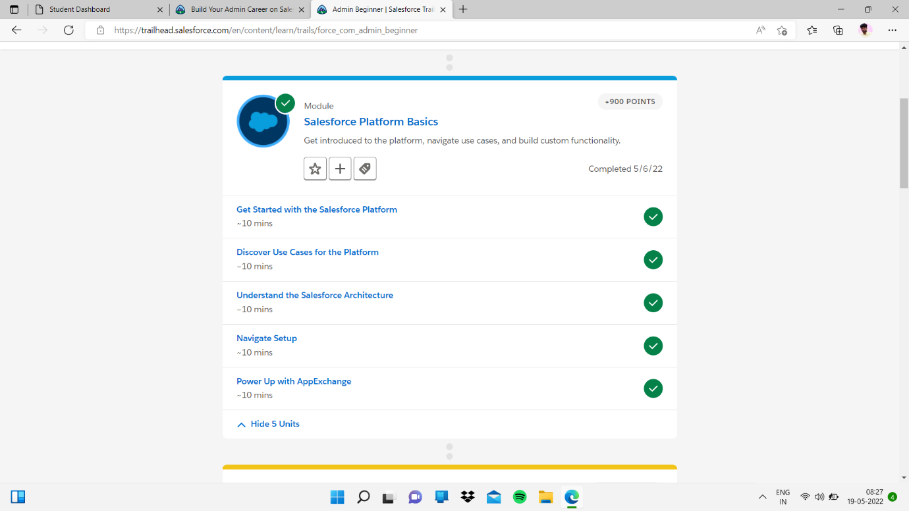

Sub topic:- Understand the Salesforce Architecture

In this I completed quiz

